Vodafone-Egypt
Technology
Change Management Process
Version 5.1

 | Name | Job Title/Department | Signature & Date
Prepared by: | Hany Abdel-Aziz | Technology Change Management
Prepared by: | Mohamed ElGendy | Manager, Charging Support
Prepared by: | Mohamed Elmasry | Sr. Supervisor, Data Network
Prepared by: | Mohamed El-Sheikh | SLA Management Technical Expert
Approved by: | Haitham Taie | Sr. Manager, Mobile Internet & Enterprise SM
Approved by: | Hatem Raslan | Service Mgnt. Senior Technical Lead
Approved by: | Hassan ElSokkary | Service Management
Approved by: | Samah Khamis | Customer Experience
Approved by: | Mohamed Khalil | Regional Operations
Approved by: | Osama Said | Products and Services
Approved By | Yasser Rashwan | NW Engineering
Approved by: | Essam Lala | IT Operations
Approved by: | Waseem Darweesh | Planning & Strategy
Approved by: | Tony Dolton | Chief Technical Officer

CHANGES RECORD
Sr. | Type of Change | New Version Number | Change Requester | Changed Sections | Date
1 | Minor | 1.1 | Mai Gamal | Deleting 2 extra flowcharts  "Roll-Out Work Orders" and "Construction and Maintenance” | Aug 9, 2004
2 | Minor | 1.2 | Mai Gamal | References | Aug 17, 2004
3 | Minor | 1.3 | Yasser Badr | References | Mar 30, 2005
4 | Minor | 1.4 | TD-SP | Adding Shut down process | May 12, 2005
5 | Major | 2.0 | SOX team | Merge between Mobile Network Change Management & IT Change Management | Feb. 13, 2006
6 | Major | 3.0 | Ahmed Abdel Dayem | New Template, & Measurements table | Jan 18 , 2006
7 | Minor | 3.1 | SOX Team | Add Changes to new IT systems to scope | Dec 14, 2008
8 | Major | 4.0 | Change Management Team | Update the process to reflect real-life process application and to make the process more compliant with ITIL | Feb 20, 2011
9 | Major | 5.0 | Quality stream initiative team:  Hany Abdel-Aziz  Mohamed ElGendy  Mohamed Elmasry  Mohamed El-Sheikh  Haitham Taie | Modify the process to include all Technology systems and services in a unified process | Feb 15, 2012
10 | Minor | 5.1 | Hatem Raslan  Hany Abdel-Aziz | Some modifications in R&R, adding Glossary and other minor changes | May 15, 2012

Table of Contents

1. Introduction 4
2. Goals 5
3. Objective 6
4. Scope 6
4.1. Proactive Changes 6
4.2. Reactive Changes 6
5. Process description 7
5.1. Process diagram 7
5.2. Change initiation 8
5.3. Change review and filtering 8
5.4. Change Evaluation 9
5.4.1. Change Classification 9
5.4.2. Change Prioritization 11
5.4.3. Risk assessment 14
5.4.4. Change Scheduling 14
5.5. Change Authorization 14
5.5.1. CAB committee 15
5.5.2. Emergency CAB 16
5.6. Change Implementation 16
5.7. Change Closure 17
5.8. Tracking and Reporting 17
5.9. Change Management, Incident & problem Management: 18
5.10. Change Management and Service Transition: 18
5.11. Process Flowcharts 20
5.11.1. Process Flowchart - Normal Change 20
5.11.2. Process Flowchart - Standard Change 21
5.11.3. Process Flowchart – Emergency Change 22
5.12. Roles and Responsibilities 23
6. Liabilities 25
A. Appendix 1 26
B. Appendix 2 26
C. Appendix 3 27
D. Appendix 4 26

Glossary
Term | Definition
Change | The addition, modification or removal of anything that could have an effect on Services/Systems. The Scope should include all Systems/Services.
Change Management | The Process responsible for controlling the Lifecycle of all Changes. The primary objective of Change Management is to enable beneficial Changes to be made, with minimum disruption to Services.
Change Request | Is the formal first step to implement a change. Change requests should all be created on BMC Remedy.
BMC Remedy | Software used in controlling the Change Management process
RFC | Request For Change (sometimes referred to as Change Request)
Implementation | Applying the required configuration to the production environment to realize a certain change
Rollback | Restore the original state of a service, system, configuration in order to overcome a problem in the implementation of a change
ITIL | Information Technology Infrastructure Library.
SLA | Service Level Agreement  An Agreement between a Service Provider and a Customer. The SLA describes the Service, documents Service Level Targets, and specifies the responsibilities of the Service Provider and the Customer. A single SLA may cover multiple Services or multiple Customers.  See Operational Level Agreement
OLA | Operational Level Agreement  An Agreement between a Service Provider and another part of the same Organization. An OLA supports the Service Provider's delivery of Services to Customers
PSO | Projected Service Outage  A Document that identifies the effect of planned Changes, maintenance Activities and Test Plans on agreed Service Levels.
CS | Change Schedule  A Document that lists all approved Changes and their planned implementation dates. A Change Schedule is sometimes called a Forward Schedule of Change, even though it also contains information about Changes that have already been implemented.
Change description | A brief description of the proposed change.
Change justification | A brief answer for “why do we need to implement this change?”.
Impacted services | A list of the services that will be impacted by this change and the level of this impact during change implementation,(eg: total outage, partial outage, congestion, delay…etc).
Business Impact | Impact on internal customers (such as customer care, Sales, finance..etc)
Technical Impact | List of the impacted nodes/systems due to this change.  Note: Technical impact doesn’t necessarily lead to service or business impact due to resilience for example.
Implementation risks | The potential impact on Systems/Services in case of failed change (in other words, the worst case scenario in case of change failure)
Urgency | How urgent is this change: Urgent, High, Medium or low
Implementation plan | In case of many tasks under the same change request
Term | Definition
Roll back plan | Clear description of what the implementer should do in case of failed change to get the Services/Systems back to normal operation as before the change
Pre-implementation testing reports/evidence | Evidence of testing or a date of when testing evidence will be provided (in case of UAT for example) or why pre-implementation testing is not possible
Post implementation testing/acceptance criteria | What testing scenarios should be done to confirm a successful change or a justification why post implementation testing is not possible
Proposed implementation date/time | The date and time at which we need to implement this change
Proposed change priority | Change priority: Critical, High, Medium or low (according to the predefined priority matrix)

Introduction

This document describes the change management process implemented by Vodafone Egypt Technology department to ensure:
- Standardized methods and procedures are used for efficient and prompt handling of all changes
- Ensure that all changes to services, systems and applications are recorded and that they are easily tracked
- All change requests submitted by technology teams are managed by a single focal point in order to minimize the probability of conflicting changes and potential disruption to the production environment
- All change request are approved by concerned technical staff and all impacted business parties
- Successful implementation of changes on all Vodafone Egypt technology services, systems and applications that are in production and to reduce the number of rolled back changes.
- Deliver changes promptly to meet business time scales

The Change Management process also defines the responsibility of handling Changes that will occur between the Change Manager and Change stakeholders and defines roles and responsibilities of all VFE teams involved in implementing the Change Management work flow.

Vodafone Egypt Technology change management is based on ITIL (version 3) best practices.

The following outlines the requirements to proceed with the implementation of the Change Management process:

- Formal signoff on the contents of the Change Management process.
- Assignment of all Roles and Responsibilities outlined in this document.
- The customization of BMC Remedy system to enable the procedures described in this process.

This process version will be reviewed and assessed after 3 months of implementation Goals

Respond to the customer’s requirements for services, systems and applications changes while maximizing value and reducing incidents, disruption and re-work

Objective

The objective of this process is to apply standardized procedures and criteria for managing technical changes for Vodafone Egypt technology services, systems and applications in order to ensure that changes are recorded, evaluated, authorized, prioritized, planned, tested, implemented, documented and reviewed in a controlled manner, aiming to achieve successful implementation of changes at the first attempt and minimize the impact and risks on service quality.

The process focuses on delivering an appropriate response to change requests maintaining a proper balance between the need for Change against the impact of the Change.

Scope

The Change management process is used in all cases of technical changes to Technology production hardware and software systems including the transition of new systems to production state. The procedures described by this process starts from receiving request for change until it is applied to production environment and ends by implementation confirmation and includes changes reviews & health check reports.

Proactive Changes
- Change requests to implement new projects , new services and running services modifications submitted by:
  - Products & Services
  - IT Operations
  - Regional Operations.
  - NW Engineering
  - Service Management

Reactive Changes
- Change requests submitted by operation teams to implement fixes and patches to solve problems that are submitted by

  - Products & Services
  - IT Operations
  - Regional Operations.
  - NW Engineering
  - Service Management.

Process description

Process diagram

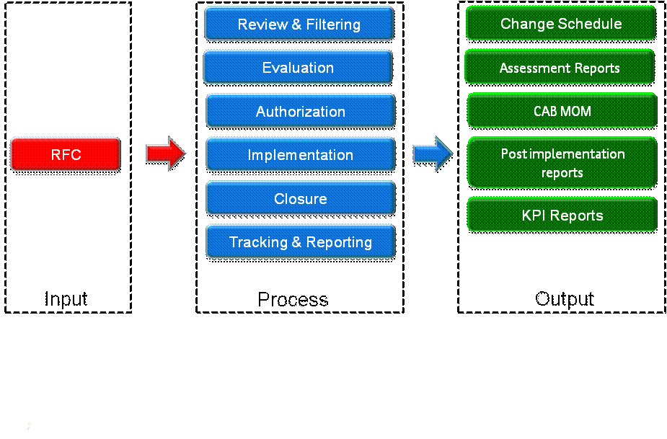

Diagram 1: Change Management Process

Diagram 2: Change request phases

Change initiation

Requests for changes that trigger this process are initiated by the Change Requester on BMC Remedy system in order to implement an activity that may affect directly or indirectly any of the technology production services, systems and applications this shall include:
- New services/systems roll out
- Patch deployment
- System upgrades
- Software new releases
- Hardware upgrades
- Hardware maintenance
- Software fixes and updates
- New feature deployments
- Incident and problem management related changes
- Power scheduled maintenance impacting technology services
- Capacity related modifications

The change initiator’s manager approval is required to transition the change request to the next phase (Review and filtering), this approval is a confirmation that the change is technically evaluated and confirmed to be valid for implementation, the RFC will still be with the “Draft” status on Remedy.

A Remedy change requests will be referenced in this document as RFC “Request for Change”.

Change review and filtering

Upon submission of a remedy RFC the change management team shall review the change request to ensure it fulfils the mandatory requirements listed below in order to be processed:
- Change description
- Change justification
- Impacted services
- Business Impact
- Technical Impact
- Implementation risks
- Urgency
- Implementation plan
- Roll back plan
- Pre-implementation testing reports/evidence
- Post implementation testing/acceptance criteria
- Proposed implementation date/time
- Proposed change priority
A change that will not satisfy the listed requirements will be returned to the change requester in order to fulfill the missing requirements. The change review results shall be communicated to the change requester within predefined period as per the Change Management agreed SLA/OLA , upon completion of change mandatory requirements , the change management to set the RFC to the “Request for Authorization” status.
The Change Management team should establish a series of SLA/OLAs with each of the Technology teams to define and agree on change requests processing timelines

Any change in the content or the proposed timeframe listed in the RFC shall be communicated to the Change Initiator once decided.

Change Evaluation

A complete remedy RFC shall be evaluated by the change management team to ensure the correct assignments for the change class, impact, urgency , priority and risk of change implementation on running services.
During the change evaluation phase the change management team may include the change initiator and implementer to study the change aspects such as the change impacted services, implementation date and time, define implementation tasks, the sequence of implementation tasks, decide the appropriate notification recipients.

Change Classification
The Change type and the priority assigned to a Change will determine the procedure of change authorization and implementation.
Changes are classified into three types of changes based on the change service impact and frequency of occurrence; these types are defined as
- Standard changes
- Normal changes
- Emergency changes
The priority will be established by assessing the Impact and Urgency levels associated with the Change, assigning a value to each, from which the priority can be identified.
This section provides the definitions for Emergency, Standard and Normal Changes. In addition, this section provides definitions for Impact and Urgency in order for the priority to be assigned.
The Change Management team will be responsible for reviewing and approving the classification of all Changes.

Standard Change (Frequent, low impact changes)
A standard change is a change to a service for which the approach is pre-authorized by change management where the approval of each occurrence will be granted by the change requester’s manager and change implementer’s manager as a delegated authority for that standard change.

A standard change has an accepted and established procedure to provide a specific change requirement, it is of limited scope, low risk and high iterative frequency that can be implemented with confidence of not disrupting the business operation.
The crucial elements of a standard change are that:
- There is a defined trigger to initiate the RFC
- The tasks are well known, documented and proven
- Authority is effectively given in advance
- Budgetary approval will typically be preordained or within the control of the change requester
- The risk is usually low, and always well understood
To qualify a change to the standard change class a request shall be raised to the change management team by the change owner or stakeholder, upon qualifying a change to the standard change class the change will be added to standard changes class on Remedy and hence follow the standard change procedure defined in section 6.11.2.
A list of changes defined as standard is defined and maintained by the change management team (Appendix 1 – list of standard changes).
Standard changes are to be implemented in maintenance window.

Emergency Change
Emergency change is intended to repair an error in a service that is impacting the business to a high degree and a workaround will not be sufficient. Changes intended to introduce immediately required business improvements are handled as normal changes, assessed as having the highest urgency, urgency unless a senior management approval is given to be treated as emergency change.
Emergency changes will follow an expedited process to ensure flexibility to satisfy business needs, there will still be a need to review, authorization, pre and post implementation testing, Emergency changes may document some details retrospectively.
The number of emergency changes proposed should be kept to an absolute minimum, because they are generally more disruptive and prone to failure.
Emergency changes are reserved for changes intended to repair an error in a system, a service or an application that is negatively impacting the business to a high degree or changes that responds to ad-hoc commercial requests, and it could be used for urgent deployments requests triggered by the commercial teams for strategic services or promotions that could not sustain the normal process timelines.
An Emergency change shall follow the Emergency changes procedure defined in section 6.11.3.

Normal Change
Normal change is any change on technology services that is not defined as a Standard or Emergency change; it follows the full change management process.
A Normal change shall follow the Normal changes procedure defined in section 6.11.1.

Change Prioritization
Prioritization is used to establish the order in which changes put forward should be considered, it is generally a classification to identify the relative importance of a Change.
The priority of a change is derived from the agreed impact and urgency, where impact is based on the benefit the change will bring to the business or on the degree of damage and cost to the business due to the error that the change will correct whereas the urgency is a measure of how long the implementation can afford to be delayed before it has a significant Impact on the business.

The table below illustrates the defined levels of change urgency in scope of this process.
Urgency | Description
Critical | Change needs to be implemented quickly to recover an unavailable service, typically related to major incidents  Change needs to be implemented quickly to deploy a commercial strategic roll out
High | Change needs to be implemented quickly to recover an affected service ; where certain functions are unavailable to customers
Medium | Change needs to be implemented within an appropriate time frame to recover a service that is not severely impacted, but resolution cannot be deferred until next scheduled release or Upgrade  Change needs to be implemented within an appropriate time frame to deploy a new service  Change needs to be implemented within an appropriate time frame to upgrade a system or enhance service features
Low | Change needs to be implemented within an appropriate time frame to recover a service; where certain functions are degraded but still available
Table 1 - Urgency Assignment

The table below illustrates the defined levels of change impact in scope of this process.
Impact | Description
Extensive  (CAB autorization is required) | A change that meets any of the below conditions:  Impacts more than or equal to 25% of subscribers  Impacts more than or equal to 1% of Value added service customer base  Impacts more than or equal to 100 radio sites  Causing a risk on revenue more than or equal to EGP 250K  Impacts multiple IT services/systems  Impacts multiple departments (IT Services)  Impacts an IT service/system categorized as “Mission critical”
Significant  (CAB autorization is required) | A change that meets any of the below conditions:  Impacts more than or equal to 15% and less than 25% or of subscribers  Impacts more than or equal to 0.5% and less than 1% of Value added service customer base  Impacts more than or equal to 50 and less than 100 radio sites  Causing a risk on revenue more than or equal to EGP 50K and less than EGP 250K.  Affecting a complete business unit within a department (IT Services)  Impacts an IT service/system categorized as “Business critical”
Moderate | A change that meets any of the below conditions:  Impacts more than or equal to 10% and less than 15% or of subscribers  Impacts less than 0.5% of Value added service customer base  Impacts more than or equal to 10 and less than 50 radio sites  Causing a risk on revenue more than EGP 1K and less than EGP 50K  Affecting a small number of individuals (IT Services)  Impacts an IT service/system categorized as “Business important”
Minor | Any impact less than the above.
Table 2 - Impact Assignment
The priority of a change is derived from the agreed impact and urgency. Initial impact and urgency will be proposed by the change requester but may be modified in the change evaluation and authorization processes.
Priority matrix:

 |  | Impact
 |  | Extensive | Significant | Moderate | Minor
Urgency | Critical | Critical | Critical | High | Medium
Urgency | High | Critical | High | Medium | Medium
Urgency | Medium | High | Medium | Medium | Low
Urgency | Low | Medium | Medium | Low | Low
Table 3 – Change Priority Matrix
Prioritization is used to establish the order in which changes put forward should be considered.
Priority | Description | Treatment
Critical | Change is required to resolve an issue currently causing loss of revenue or service usability to a larger number of Users, a mission-critical system | Immediate action required. Emergency CAB may need to be assembled  Resources need to be allocated immediately to build such authorized Changes with a lead time equal or less than 12 hours
High | More than one project is involved in or impacted by the change  More than one service is involved in or impacted by the Change | Acceptance of the business and technical risks is required.  Review, scheduling, and Risk Acceptance are done through formal Approval via the CAB or via Emergency Committee/CAB for exceptional cases  Resources need to be allocated immediately to build such authorized Changes with a lead time equal or less than 24 hours
Medium | One or more projects are involved in or impacted by the Change  One or more services are involved in or impacted by the Change | Scheduling is required to ensure:  Coordination between groups  Management commitment of resources  Review and Scheduling are done via the CAB
Low | Straight forward implementation and roll back that has been performed many times before  Users are familiar with the Change  Involves a single service, system or application  There is generally no outage associated with the Change. | The Change is made available for Review to ensure general awareness and alignment
Table 3 – Change Priority description

Risk assessment
The potential impact on the services of failed changes and their impact on business need to be considered while evaluating a request for change, a change risk assessment should be conducted by the change management team to identify the level of risk associated with the requested change, the identified level of risk is an important factor for the CAB to decide the approval for the requested change.
The table below illustrates the defined levels of risk in scope of this process.
Risk level | Description
Level 1 | No service impact
Level 2 | Low impact, Low probability
Level 3 | Low impact, High probability
Level 4 | High impact, Low probability
Level 5 | High impact, High probability
Table 4 – Risk levels

Change Scheduling
It is recommended that Change Management schedule changes to meet business rather than Technology needs, to avoid critical business periods and reduce the change impact on live services.
Normal changes should always be implemented in the defined maintenance window, unless a justified and approved reason is identified for a specific change or change type.
Change Management coordinates the production and distribution of a weekly change schedule (CS) and projected service outage (PSO). The CS contains details of all the changes authorized for implementation during a week and their proposed implementation date and time. The PSO contains details of changes to agreed SLAs and service availability because of the currently planned CS. The CS shall be discussed and approved by the CAB prior to distribution.
Non-Emergency changes that are requested and approved for implementation within an announced CS period should be communicated by change management to all operations teams, using the most effective methods within the implementation date business hours to ensure full operational readiness and awareness prior to change implementation.

Change Authorization

Formal authorization is obtained for each change from a change authority that may be a role, person or a group of people. The level of authorization is defined by the type, priority and risk levels.

The CAB (Change Advisory Board) is responsible for the authorization of all changes categorized as normal changes, standard changes are pre-authorized by the CAB hence no need to apply for the CAB approval for every standard change occurrence where the service owner and requester manger approval shall be sufficient to authorize the change implementation. To ensure responsiveness to business requirements Emergency changes following the expedited change management process shall be authorized by the ECAB committee.

CAB committee
The Change Advisory Board (CAB) is a body that supports the authorization of Extensive and Significant changes, prioritization, review of changes and review of changes that were implemented.
The CAB (Change Advisory Board) committee include the Change Management team and members that represent all Technology and selected business teams representatives. Members of the CAB should be capable of ensuring that all Changes are adequately assessed from both a business and a technical viewpoint. Membership of the CAB should represent the following areas:
- Change management
- Tech-IM
- Technical Service Desk
- Help Desk
- VIS Service Desk
- Technology Service Level Expert
- IT Operations teams managers
- Service Management teams managers
- Regional Operations teams managers
- Relevant Products & Services teams
- Customer Experience teams managers
- Relevant Business team representative (Customer care, commercial, finance…etc)
- Any participant the change manager finds necessary according to the change nature
CAB meets on weekly basis, the CAB meeting is owned by the change management team.
CAB will review changes with Extensive and Significant impact to be implemented within 1 week.

* A list of each service relevant Products & Services teams and Business team representatives is built and maintained by change management team.

The aim of the CAB committee is:
- Review all proposed RFC with Extensive and Significant impact and discuss the evaluation results
- Approve the change proposed implementation date and time
- Ensure minimizing/eliminating the Change impact on business services
- Ensure the proposed change does not impact any committed service SLA
- Review post-implementation reports of:
  - Changes rolled back in last week and make sure that an IR has been issued of Extensive and Significant changes that were rolled back.
  - Changes that exceeds the planned down time
  - Incidents related to the implementation of changes that were reported within 3 days of implementing the change.
- Review and approve the weekly change schedule
- Review outstanding (Postponed) changes
- Review of detected unauthorized changes

CAB committee shall have a scheduled weekly meeting but also can be invited to ad hoc meetings for ad hoc changes or to discuss the same change in more than one meeting.

Emergency CAB
Emergency CAB (ECAB) is a small form of Change Advisory Board who makes authorization decisions for Emergency Changes where the committee members are of higher level of organizational authority than the regular CAB committee members and are only relevant to the service in scope of the proposed Emergency change.

ECAB meetings are ad-hoc meetings that could be in the form of conference call chaired by the change management and includes the change requester, implementation groups management, requester team management to negotiate all change aspects such as risk of not implementing the change, business impact date/time, implementation plan, rollback plan, and change approvals.

The number of emergency changes should be kept to an absolute minimum, because they are generally more disruptive and prone to failure.

Emergency changes are reserved for changes intended to repair an error in a system, a service or an application that is negatively impacting the business to a degree higher than the change risk or changes that responds to ad-hoc commercial requests.

Change Implementation

Authorized RFCs should be passed to the relevant technical groups for the technical built and implementation of the changes through BMC Remedy tasks.

The approval of the implementation team manager on the change requests is a confirmation that the change is technically evaluated and confirmed to be valid for implementation.
Change Management has the responsibility for ensuring that changes are implemented as per approved schedule, .Prior to and during the implementation of changes the change requester or project manager has the role of co-coordinating the implementation activities in case several technical teams are involved as well as acting as SPOC to business and management teams for change updates during the implementation stages.

Roll back procedures should be prepared and documented in advance as it is a mandatory requirement for change processing so that if errors occur during or after implementation, these procedures can be quickly activated with minimum impact on service quality. The Change requester, project manager or Implementation team manager has the authority and responsibility for invoking roll back procedure

Change Management has an oversight role to ensure that all changes are thoroughly tested pre and post the implementation.

Change Closure

On completion of the change, the post- implementation tests results should be reported to change management and requester for evaluation upon which the change is either closed with a successful status or updated for a second attempt.

Changes testing and acceptance shall be conducted by a separate unit than the change implementer whenever possible, in this case the post changes testing function in Customer experience team will be responsible for post implementation testing.

Any incidents that may occur on the services/systems subject to an implemented change should be assessed by the relevant technical team and change management team to verify if it is related to that change, the Remedy incident record shall be linked to the relevant change record in case a relation is confirmed.

The post- implementation tests results, change closure status and any incidents occurred due to the change are reported to the CAB in the next scheduled meeting.

Tracking and Reporting

Change Management shall measure the speed and effectiveness with which the Technology department responds to business needs and provide visibility to the Changes and their status for all stakeholders.

The change management team shall measure and report the below process KPIs:
- Number of changes which met the customer’s agreed requirements
- Average time to implement a change based on urgency/priority/change type
- Number of incidents attributable to changes
- Number of planned vs. unplanned changes (Emergency changes)
- Number of failed changes
- Frequency of change (by service, business area, etc.)
- The number and percentage of Changes rolled back successfully/unsuccessfully
- Number of changes with no pre-implementation testing.
- Number of unclosed changes that exceeds their planed date/time.
- No of modification done by the change management team to measure workload.
- Number of implemented changed but still opened.
- Number of Rejected changes per team/reason.
- Number of changes per change type (standard, normal and emergency)
- Average time elapsed from change creation till it becomes fully approved./change size.
Change management shall conduct a post implementation survey for Extensive and Significant changes to measure the accuracy of change request evaluation and planning, the results of the survey shall be discussed in regular CAB meetings, survey template in Appendix 3

Change Management, Incident & problem Management:

All changes requests initiated to resolve an incident or resulting of problem management analysis to eliminate a fault root cause (reactive changes) should be linked to the incident record on the Remedy system.

Such changes will specify the Remedy field “Change Reason” as “Fix/Review” and reference the relevant incident ID in the Relationship field.

All incidents for which the analysis indicates it is resulting of a change implemented prior to the incident should be linked to the change request record on the Remedy system.

The Technology operations teams shall have a daily meeting in which all changes planned for the day are discussed in order to ensure operational alignment and avoid any conflicts in changes implementation activities that may result in unpredictable results

Change Management and Service Transition:

New systems/services transition from design and development to operational state shall be through the Standard class change procedure referenced in this document, strict measures should be applied to ensure the stability of the new rolled out services and full awareness of all the concerned parties.
For systems/ services transitioning to operations in phases, the phases should be clearly defined and stated in the initial change request, and all the change requests for the following phases till the final system/service launch change should all be linked on Remedy system to maintain the system/service roll out records for tracking and analysis.

Pilot projects and system/service pre-production implementations on production environment shall be implemented through the Normal class change procedure where the system/service transition from pilot to full operational state to be through a standard change request to ensure the appropriate controls are applied for the system/service transition to operational state

All cases of new service/system transition to production shall have a final standard change request to declare that the new service/system will be transitioned to production. The approval of this final change request shall include system/service owner, stakeholders and relevant support teams to ensure all the stakeholders are informed

Systems and services retirement and decommissioning shall be implemented through the Standard class change procedure, to ensure all the stakeholders are informed and any necessary controls are maintained.

Process Flowcharts

Process Flowchart - Normal Change
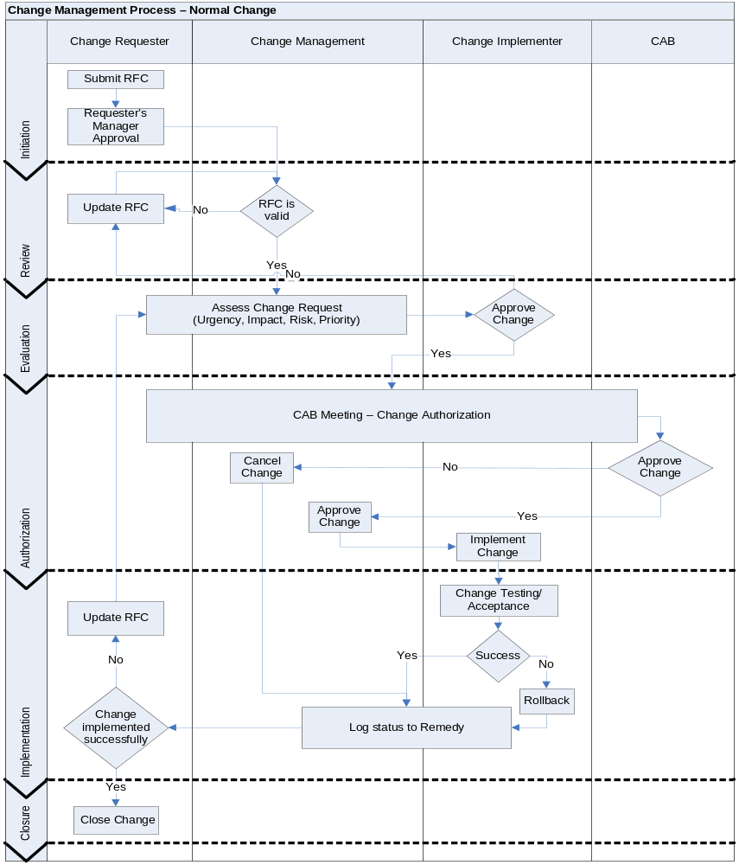

Process Flowchart - Standard Change
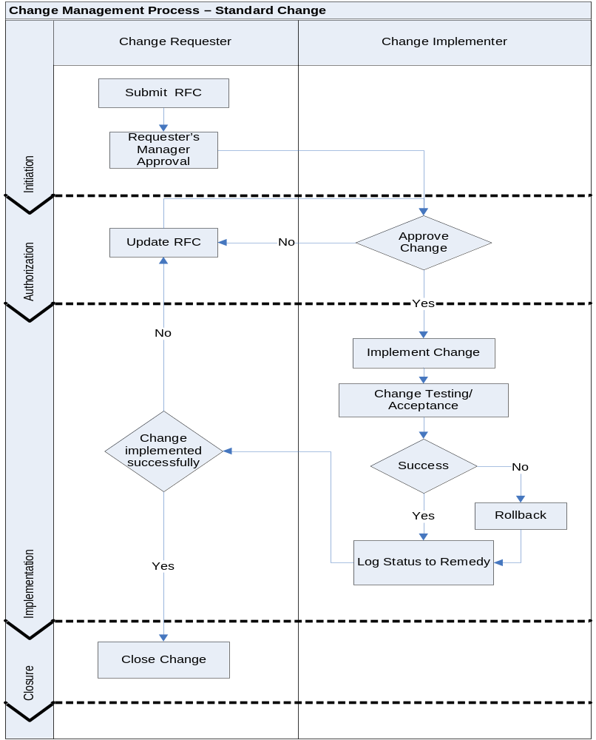

Process Flowchart – Emergency Change
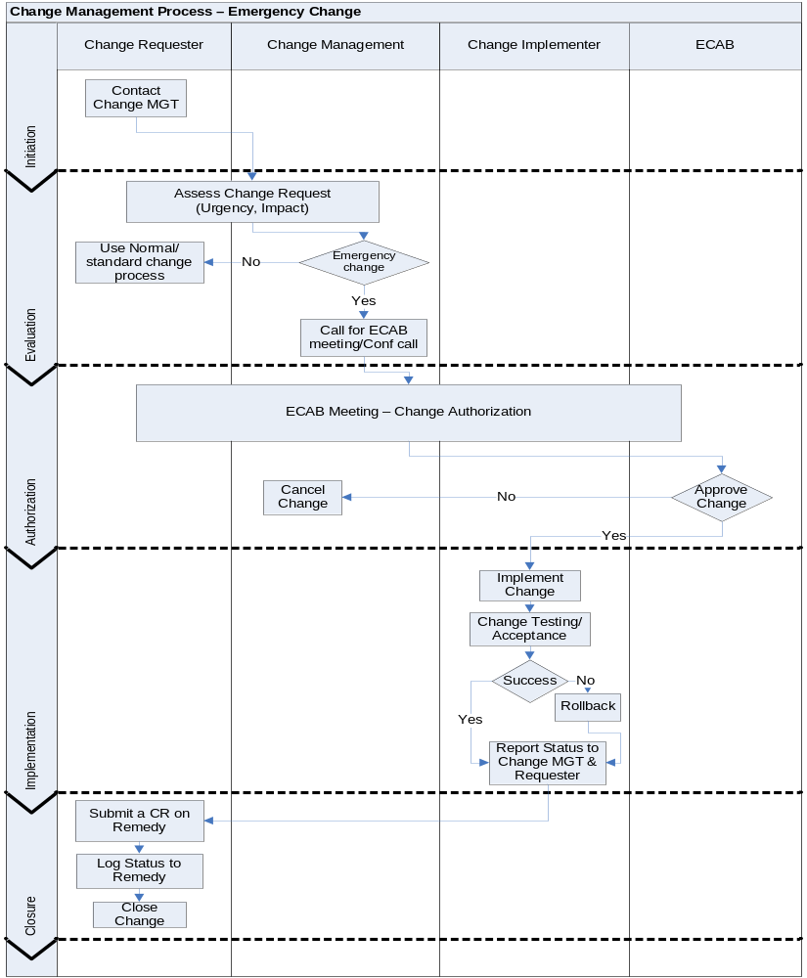

Roles and Responsibilities

The Roles in the Remedy Change Management process are:

- Change Management Team
- Change Requestor
- Change Assignee
- Change Implementer
- Change Approver
- CAB
Each one of the above roles is responsible of part of the change request Remedy data that must be fulfilled in order to minimize the impact of the change request and to clarify the responsibilities and actions required from the implementers. Each one of them should be an authorized user Remedy Change Management user. The process of authorizing and Remedy user is controlled by IT O&S Security Operation Team.
An audit trail is maintained in Remedy so that all activities are logged for later audit or investigation

Role | Role Description | Responsibilities
Change Management Team | The change management team is the one central authority that asses and controls changes to all managed systems | - Own and Manage the change process.  - Review and evaluates change requests.  - Study and communicate the impact and risks of planned changes  - Prioritize submitted change requests  - Chair the CAB and the Emergency CAB committees meetings.  - Represent the CAB in approving Change requests.  - Issues approved CAB changes schedule  - Ensure appropriate level of authorization for changes.  - Manages & controls stages targeting CR completion in the required duration.  - Issues change management process KPI reports and post implementation surveys.  - Periodic review and update to the change management process.  - Conduct periodic awareness campaign for process stakeholders.
Change Requestor | Change Request initiator | - Initiate/Log the change on Remedy system  - The change requester should specify a clear description for the below items in the submitted change request:  - Change description  - Change justification  - Impacted services  - Business Impact  - Technical Impact  - Implementation risks  - Proposed change Urgency  - Proposed change impact  - Guarantee that proper testing has been conducted prior to initiating the Change Request (where pre-implementation testing is applicable)  - Define Planned Start and end Dates for the Change Request  - Include a clear implementation plan  - Include a clear roll back plan  - Include a clear post implementation test plan  - Confirm and close changes after implementation  - Manages the implementation of major changes (Project Management)  - Coordinates between different implementers. (Project Management)
Change Assignee | The change owner who is capable of delivering the change request status and post implementation checks. In most cases this role is assigned to the requester | - Control the post production health checks in coordination with the change implementers and change management team  - Reports the status of the change request post the implementation to the change management
Change Implementer | Responsible of implementing the Change request (or part of it) on the production using the guidelines in the implementation plan. | - Implement the Change plan for approved changes  - Close all the assigned Tasks after the implementation of the change request, with the status of the task  - May conduct the post implementation tests in coordination with the change assignee and change management team
Change Approver | Responsible for authorizing and approving the implementation of proposed change requests, the approver may be Technical (Development or Support) or Business approver. | - Approve Change requests after studying the impact with the Change Management team  - Assess the Change Implementation Date/time and help select the best suitable time that minimizes the Change Business impact.
CAB | Change Advisory Board is the body that supports the authorization of Extensive and Significant changes, prioritization, review of changes and review of changes that were implemented | - Review all proposed RFC and discuss the evaluation results  - Approve the change proposed implementation date and time  - Ensure minimizing/eliminating the Change impact on business services  - Ensure the proposed change does not impact any committed service SLA  - Review post-implementation reports  - Review and approve the monthly change schedule  - Review outstanding (Postponed) changes  - Review of detected unauthorized changes
ECAB | Emergency Change Advisory Board is the body that supports the authorization of emergency changes | - Assess proposed emergency change requests  - Approve the change proposed implementation date and time  - Ensure minimizing/eliminating the Change impact on business services  - Ensure the proposed change does not impact any committed service SLA
Table 5 – Roles & Responsibilities

Liabilities

No change is allowed to be implemented without a Remedy Change Request. The change management process should be strictly followed and applied. Any violation to the change management process, the Change Manager will conduct technical investigations and the results will be sent to Management for action.

Appendix 1

List of pre-approved standard changes
(Template- the actual list shall be continuously updated and maintained by the Change Management team)

Change Name | Change Description | Change Owner | Change Requester | Change Implementer | Approvers | Pre-approval date

Appendix 2
Service CAB committee members
(Template- the actual list shall be continuously updated and maintained by the Change Management team)

Service | CAB Committee

Appendix 3

Service ECAB committee members
(Template- the actual list shall be continuously updated and maintained by the Change Management team)

Service | Change Priority | ECAB Committee

Appendix 4
Change Management Post-implementation Survey
(Template- the actual survey shall be continuously updated and maintained by the Change Management team)

Date :
Project :
CR# :
Change date/time :
Change Initiator :

Evaluation Point | Feedback
Please mention any service/system that exceeded the planned outage duration
Please mention any service/system that was back to normal operation earlier than the planned downtime
Please mention any problem in the communication process involved during the change preparation and implementation
In general, does the change implementation went as planned?
Please mention any improvement you may find important to be taken into consideration in similar future changes

